**Oracle Administration Services**

**OEM Agent Installation**

Submitted to



**By**



CIS, Wipro Limited

Document Details

|  |  |
| --- | --- |
| Project Name | Innogy SE |
| Account | CIS |
| IT Component/Application Title | OEM Agent Installation |
| Current Version | 1.1 |
| List of Contributors | Balaji Ankalle,Sreya Puthukudy |
| Customer Contact Information |  |

Version History

(All revisions made to this document must be listed in chronological order. All revisions must be approved. Review and Approval can be done by an internal source or by the customer)

|  |  |  |  |  |  |
| --- | --- | --- | --- | --- | --- |
| Version | Date of Revision | Description | Author | Reviewed By | Approved By |
| 1.0 | 01-01-2018 | Version 1 | Balaji Ankalle | Ajay Zende | Santosh Badiger |
| 1.1 | **15/12/2018** | **Updated the content** | **Sreya Puthukudy** | **Jiten Pansara** | **Santosh Badiger** |

Document Distribution List

|  |  |  |
| --- | --- | --- |
| **Sr. No** | **Name and Company** | **Purpose** |
| **1** | RWEIT-ORACLEDBA | **This document is about the Installation of OEM Agent on database host. Post OEM agent installation; relevant database Targets on the Host can be configured in OEM Repository for Management & Monitoring purpose using OEM.** |
| **2** |  |  |

**TABLE OF CONTENT**

1. Purpose 5

2. Scope 5

3. Prerequisites for OEM Agent 5

4. Steps to Configure OEM Agent 5

# Purpose

This document has been prepared to support with the technical steps required for OEM Agent Installation.|:dg&hx ja)Mz0

# Scope

This document is prepared for RWE UK Wipro Oracle team and provides the steps to configure OEM Agent on host.

# Prerequisites for OEM Agent:

* Validate the /etc/hosts on the target host and ensure hostname entry along with the relevant IP details exists.
* File system /u01/OEM/oracle (Size 15 GB) to be created
* Get Sudo access for oracle User to execute the following commands: -

/usr/sbin/slibclean  
/usr/bin/id  
/u01/OEM/oracle/Agent/agent_13.1.0.0.0/root.sh  
/u01/OEM/oracle/Agent/agent_13.1.0.0.0/sysman/install/agentDeploy.sh

# Steps to Configure OEM Agent:

* Open OEM Console and navigate to Add Target – Add Target Manually

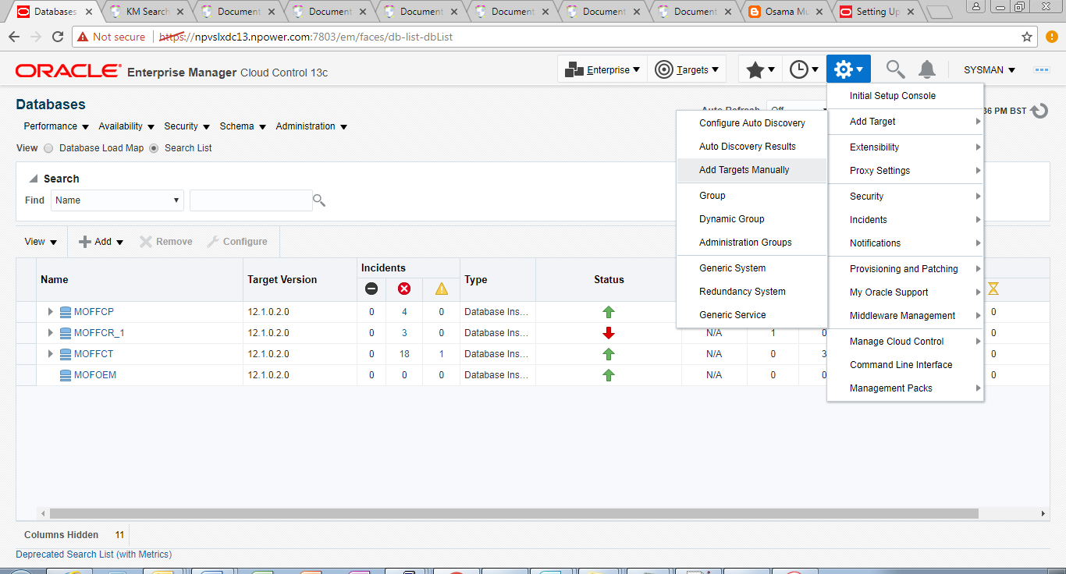

* Select install agent on host (Add Host Target)

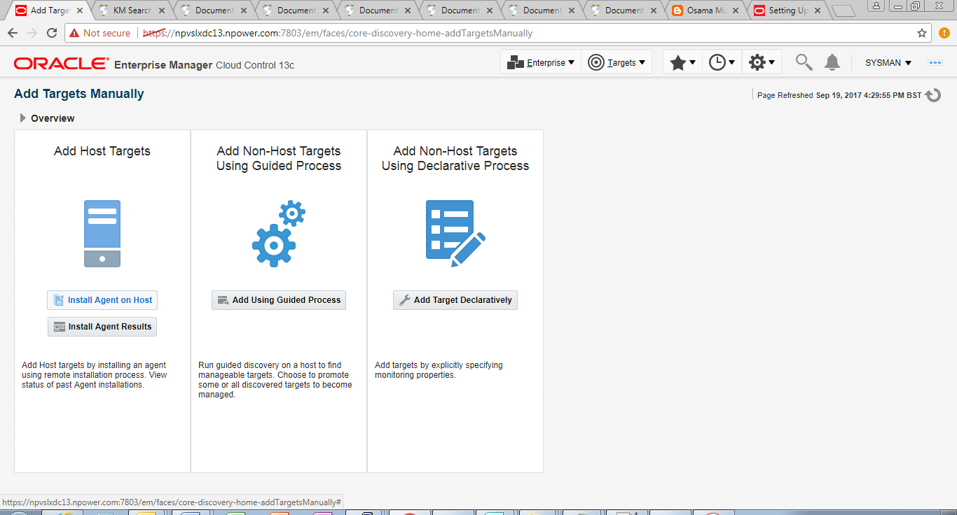

* Select the Host and Platform on which Agent needs to be installed

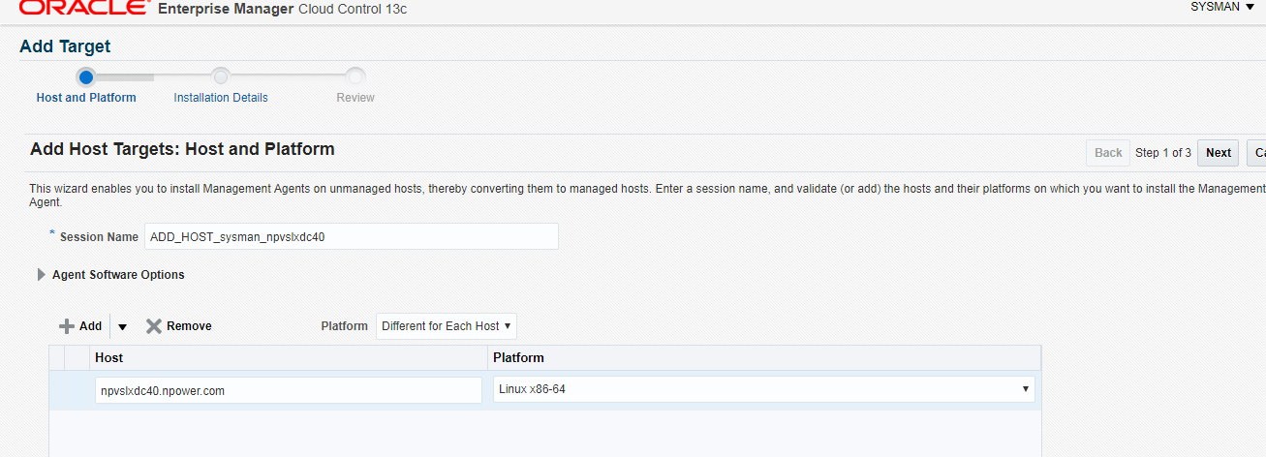

* Select Appropriate OEM Agent Base Directory, Instance Directory and provide Named credentials for host connectivity (oracle user)

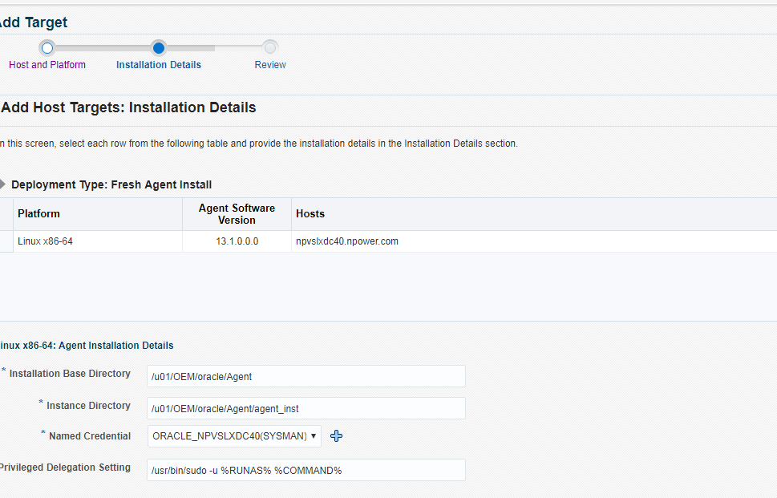

* Review the configuration and Deploy Agent.

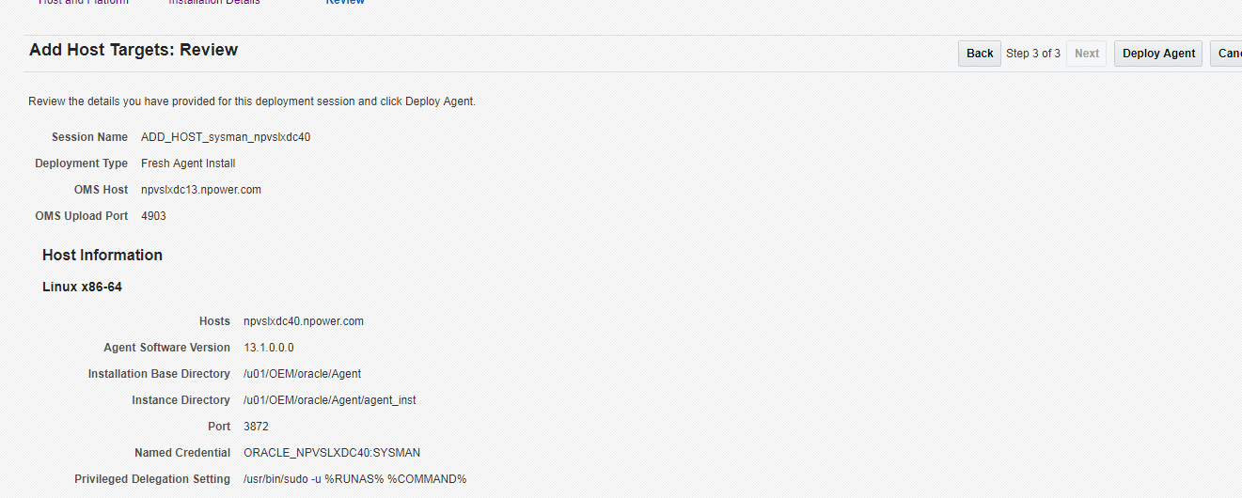

* Below is the Summary during Deployment stage. 